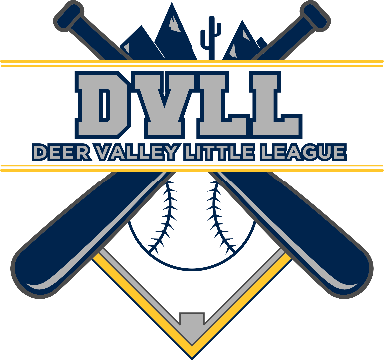 | Deer Valley Little League  P.O. Box 11120  Phoenix, AZ 85318-1120  www.DVLL.org

Levels of Sponsorship Fall 2021
Available Levels
Grand Slam $1000
This level includes:
- A banner will be hung on the fence with your company name and logo.
- Your company’s logo will appear on the sponsorship page of the DVLL website.
- A field will be named after your company and appear on all schedules for the duration of the season.
- Your logo will appear on all correspondence coming from the league (including emails and paper printed materials).
- Your company will receive a picture plaque to hang in your business location.

Home Run $500
This level includes:
- A banner will be hung on the fence with your company name and logo.
- Your company’s logo will appear on the sponsorship page of the DVLL website.
- Your logo will appear on all correspondence coming from the league (including emails and paper printed materials).
- Your company will receive a picture plaque to hang in your business location.

Triple $300
This level includes:
- Your company’s logo will appear on the sponsorship page of the DVLL website.
- Your logo will appear on all correspondence coming from the league (including emails and paper printed materials).
- Your company will receive an appreciation plaque to hang in your business location.

Double $200
This level includes:
- Your company logo will appear on the sponsorship page of the DVLL website.
- Your company will receive an appreciation plaque to hang in your business location.

